Problem 1: Payback Period
Question:
A project costs Rs. 100,000 and is expected to generate the following cash inflows:
Year | Cash Inflow (Rs.)
1 | 25,000
2 | 30,000
3 | 35,000
4 | 40,000
Find the payback period.
Solution:
Cumulative cash inflows:
- Year 1: 25,000
- Year 2: 55,000 (25,000 + 30,000)
- Year 3: 90,000 (55,000 + 35,000)
- Year 4: 130,000 (90,000 + 40,000)
Investment = 100,000 → recovered between Year 3 and Year 4.
Amount remaining after Year 3 = 100,000 – 90,000 = 10,000
Fraction of Year 4 = 10,000 ÷ 40,000 = 0.25 years
Payback Period = 3.25 years

Problem 2: Accounting Rate of Return (ARR)
Question:
Initial Investment = Rs. 120,000
Estimated Annual Profit (after depreciation) = Rs. 20,000
Project Life = 5 years
Residual Value = Rs. 20,000
Find the ARR based on average investment.
Solution:
Average Investment = (Initial Cost + Residual Value) / 2
= (120,000 + 20,000) / 2 = 70,000
ARR = (Average Annual Profit / Average Investment) × 100
= (20,000 / 70,000) × 100 = 28.57%
ARR = 28.6%

Problem 3: Net Present Value (NPV)
Question:
Project cost: Rs. 150,000
Discount rate: 10%
Cash inflows:
Year | Cash Inflow (Rs.)
1 | 40,000
2 | 50,000
3 | 60,000
4 | 50,000
5 | 40,000
Find NPV.
Solution:
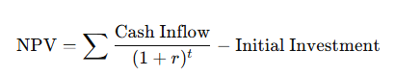

Year | Cash Inflow | PV Factor (10%) | PV (Rs.)
1 | 40,000 | 0.909 | 36,360
2 | 50,000 | 0.826 | 41,300
3 | 60,000 | 0.751 | 45,060
4 | 50,000 | 0.683 | 34,150
5 | 40,000 | 0.621 | 24,840
Total PV = 181,710
NPV = 181,710 – 150,000 = Rs. 31,710
NPV = Rs. 31,710 (Accept project)

Problem 4: Internal Rate of Return (IRR)
Question:
Initial cost = Rs. 100,000
Cash inflows: Rs. 30,000 per year for 5 years
Find IRR.
Solution:
Use PV factor for annuity:
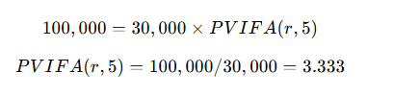
From tables:
- PVIFA(10%,5) = 3.791
- PVIFA(12%,5) = 3.605
- PVIFA(14%,5) = 3.433
- PVIFA(15%,5) = 3.353
Closest to 3.333 → IRR ≈ 15%
IRR = 15%

Problem 5: Profitability Index (PI)

Question:
Initial investment = Rs. 200,000
PV of future cash inflows = Rs. 250,000
Find PI and decide if the project is acceptable.
Solution:
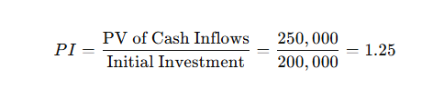
PI = 1.25 (Acceptable, since PI > 1)

